BAN 0061427

**For further information see:** [Sydney Jewish Museum Study Intensive (bne.catholic.edu.au)](https://catholicidentity.bne.catholic.edu.au/professional-development/SitePages/Sydney-Jewish-Museum-Study-Intensive.aspx)

**Contact:**

**Elizabeth Fort**

Education Officer RE

Phone: 0403048281

[**efort@bne.catholic.edu.au**](mailto:efort@bne.catholic.edu.au)

###### Thursday/Friday-

10 hours accreditation to Teach Religion in a Catholic School

###### Participants are responsible for their own meals, flights and accommodation.

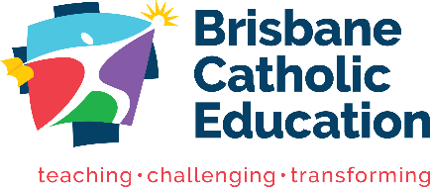

**Additional option of Shabbat meal on Friday evening**

###### Sydney Jewish Museum Study Intensive for Teachers: 11 – 12 July 2024

**Primary and Secondary content.**

**Suitable for APREs/ HODs/ Middle Leaders/ Primary and Secondary Teachers, Principals, SEOs, EOs.**

This intensive has been developed to support teachers' knowledge about Judaism, as it appears in the Religion Curriculum P-12. The intensive will be provided at Sydney Jewish Museum by the Museum staff in cooperation with BCE Religious Education Services.

**Thursday 11 July (Day 1)** will focus on understanding Jewish culture and ritual (primary and SOR curriculum)

**Friday 12 July (Day 2)** will focus on The Holocaust and Good and Evil (morality).

On Friday evening there is an option to participate in the experience of a Shabbat meal with a Jewish family – places will be limited.

* The final program will be released two weeks before departure.
* Please come prepared for an intensive program of work.
* There are plenty of restaurants and accommodation within a short walk from the museum.
* Sydney Jewish Museum - 148 Darlinghurst Road, Darlinghurst NSW 2010. [[link to map](https://www.google.com.au/maps/place/Sydney+Jewish+Museum/@-33.8789962,151.218096,17z/data=!3m1!4b1!4m5!3m4!1s0x0:0xd7db36b1dbb32fdd!8m2!3d-33.8789893!4d151.2202955)]

### Sydney Jewish Museum Study Intensive Thursday 11 July and Friday 12 July 2024

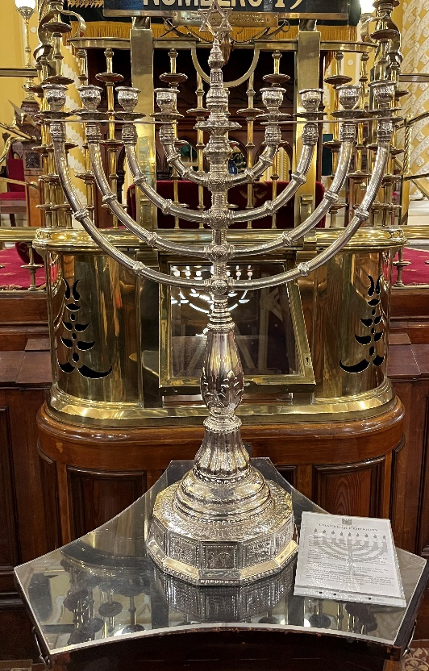

*Menorah*, image by E Fort, used with permission.